**Courseware**

**Goal:** Scala Database Application

**Database:** SQL

**Database Structure:**

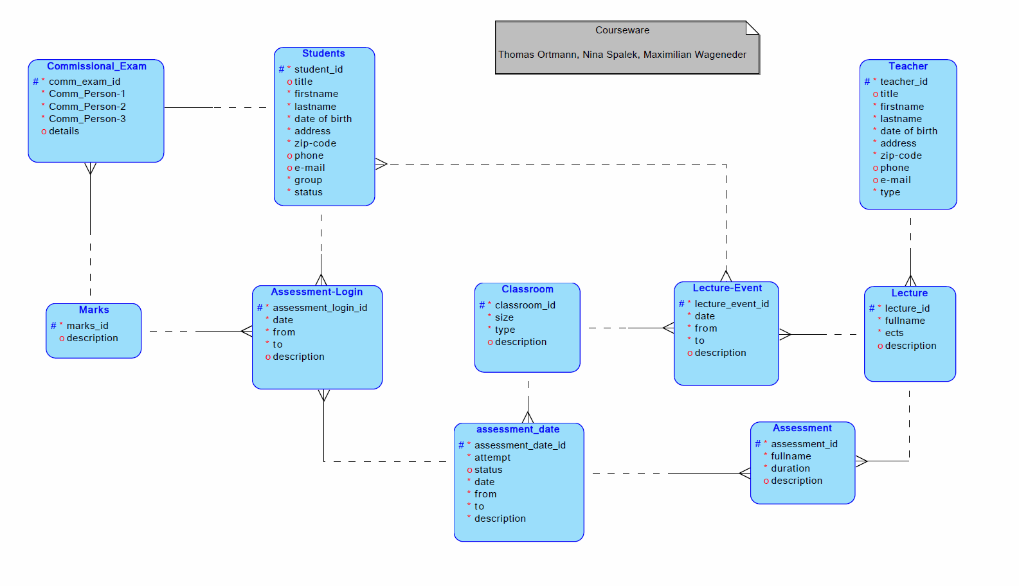

**Functionalities:**

* Selecting between different types of users
  + Students
  + Teachers
  + Admins
* Each user has a specific/logical set of operations that he can execute
  + Basic SQL operations
    - SELECT
    - UPDATE
    - INSERT
    - DELETE
  + Special predefined Queries/Reports with special functionality such as filtered overviews of timetables, marks upcoming events, exam results, etc.

**Paper prototyping:**

Main menu / Home - version 1

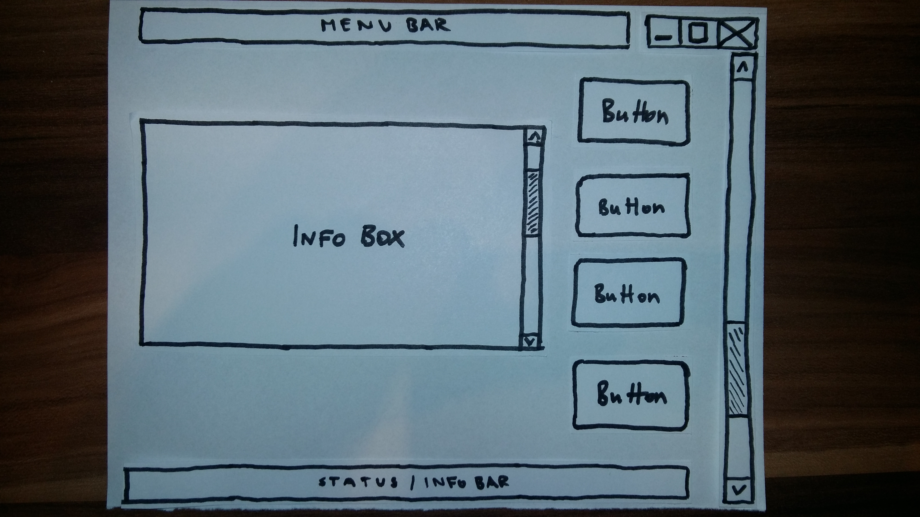

Main menu / Home – version 2

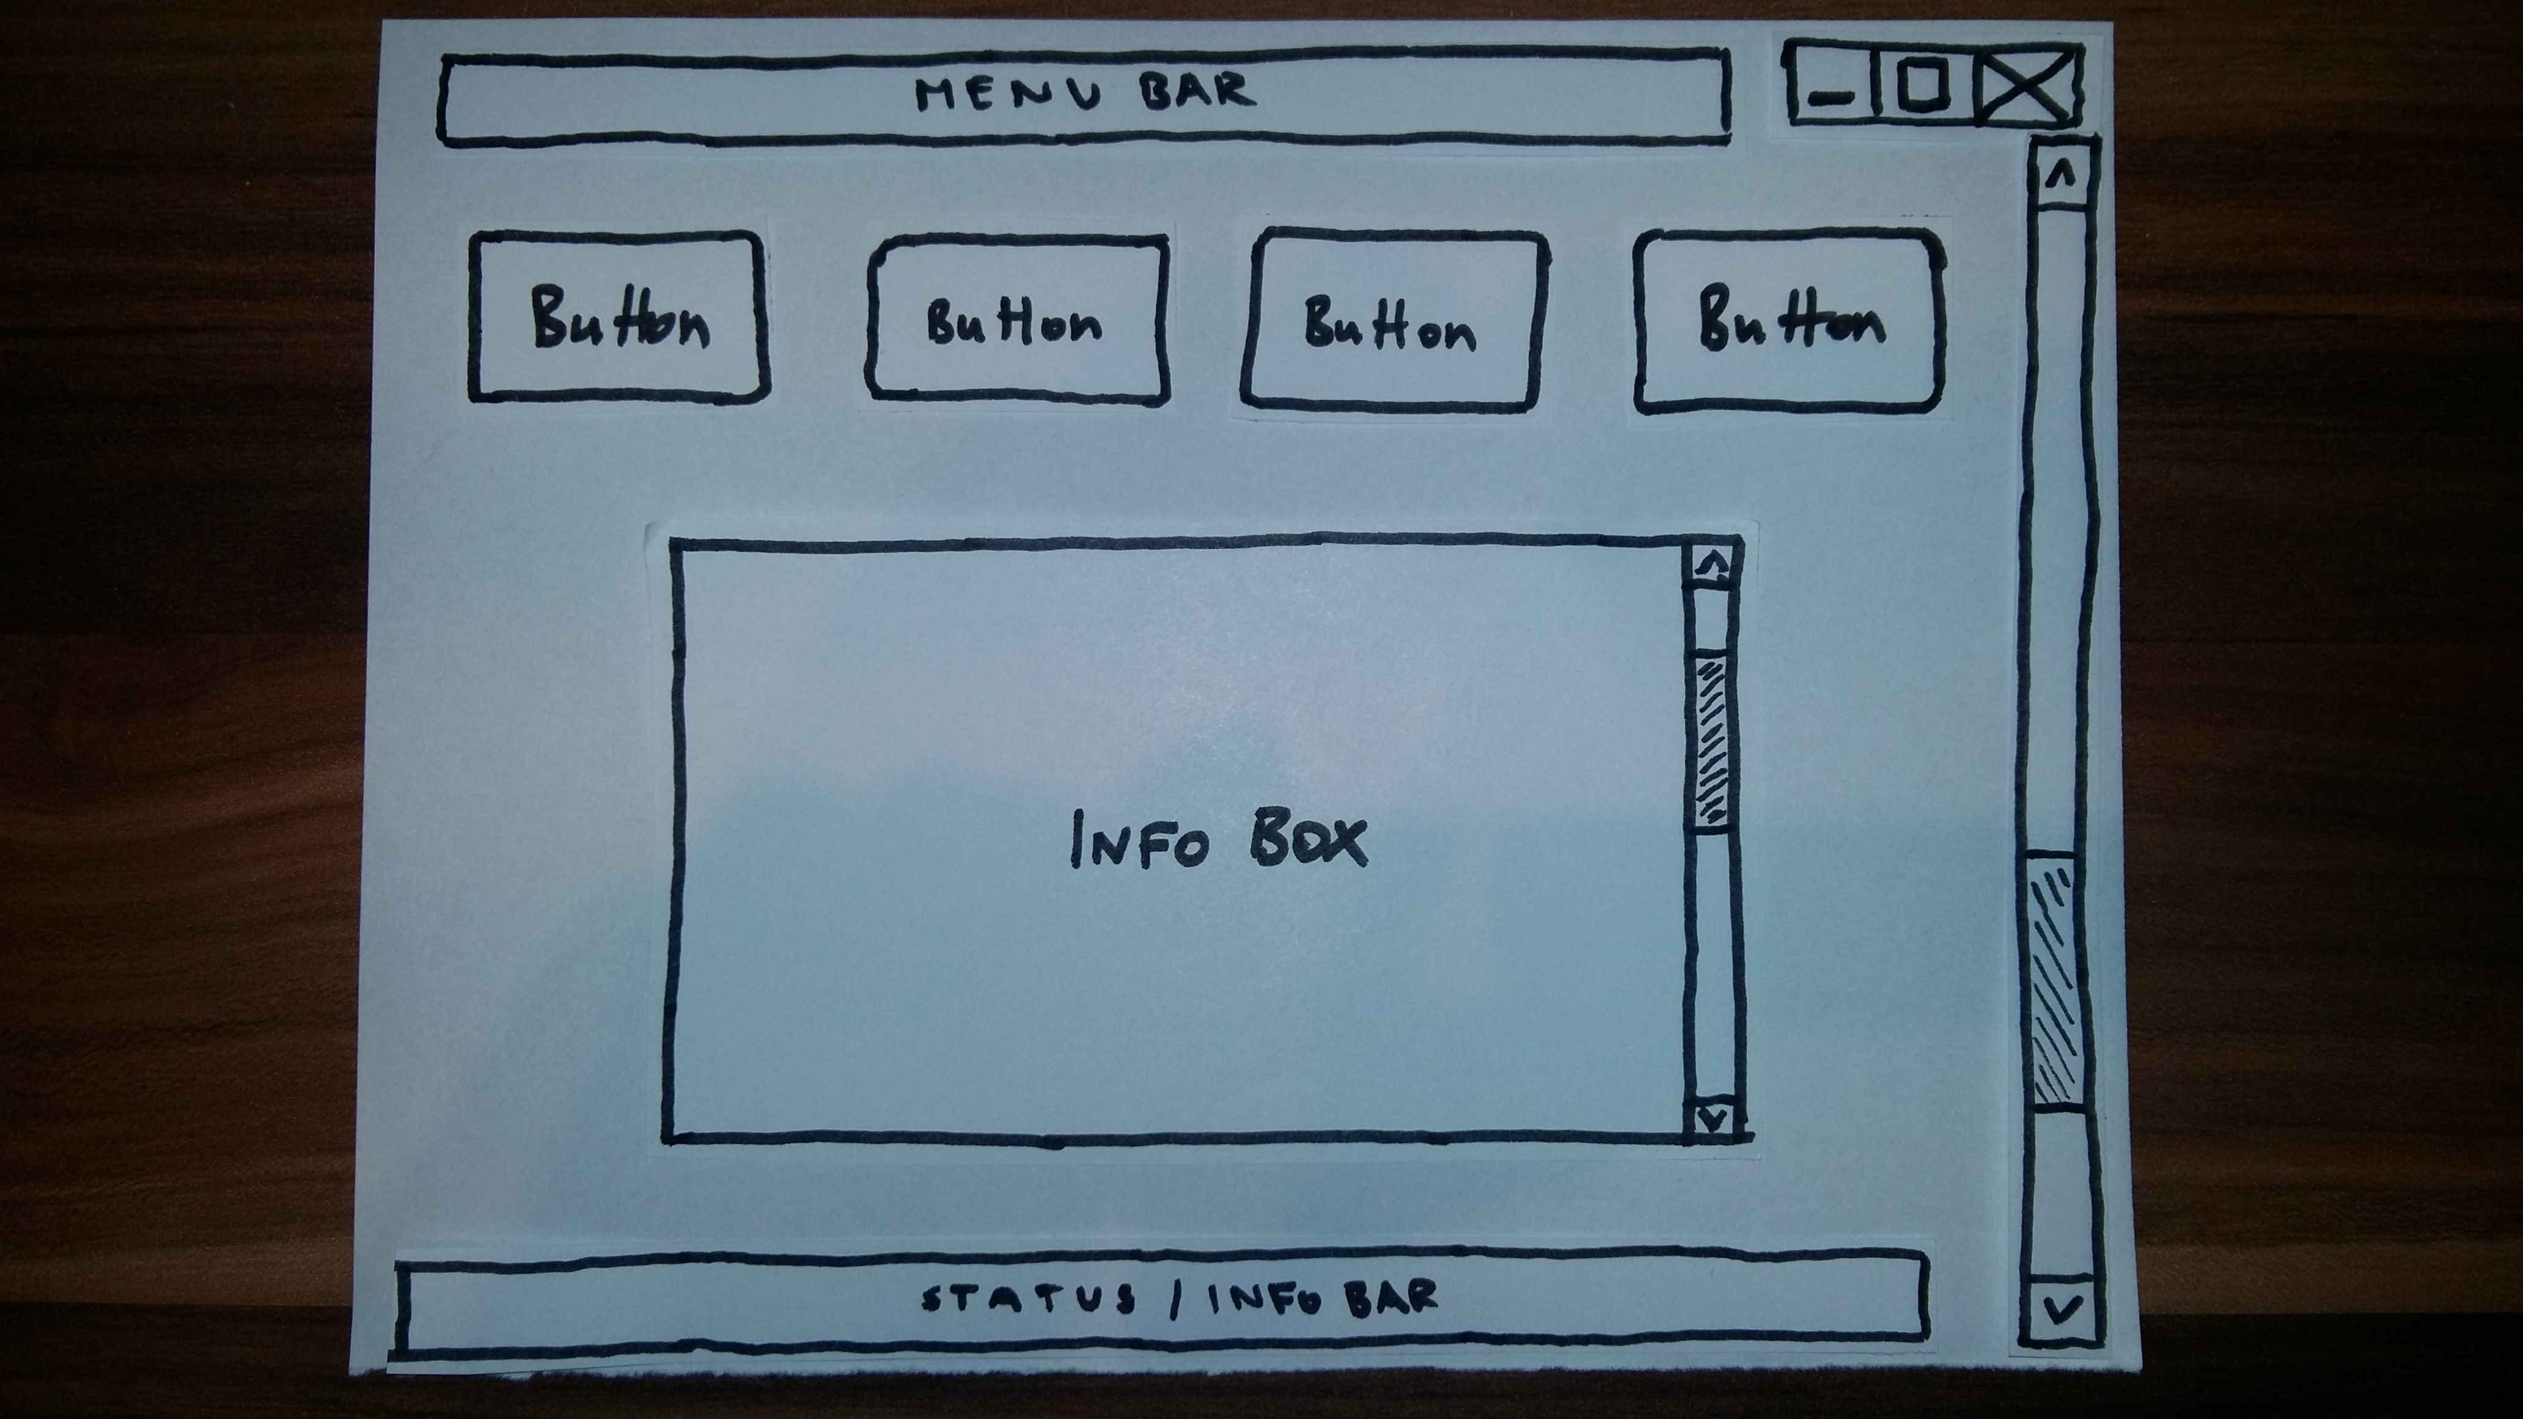

Main menu offers the selection between different submenus (users) via several buttons – each submenu offers different functionalities explained in the info box.

Submenu example – version 1

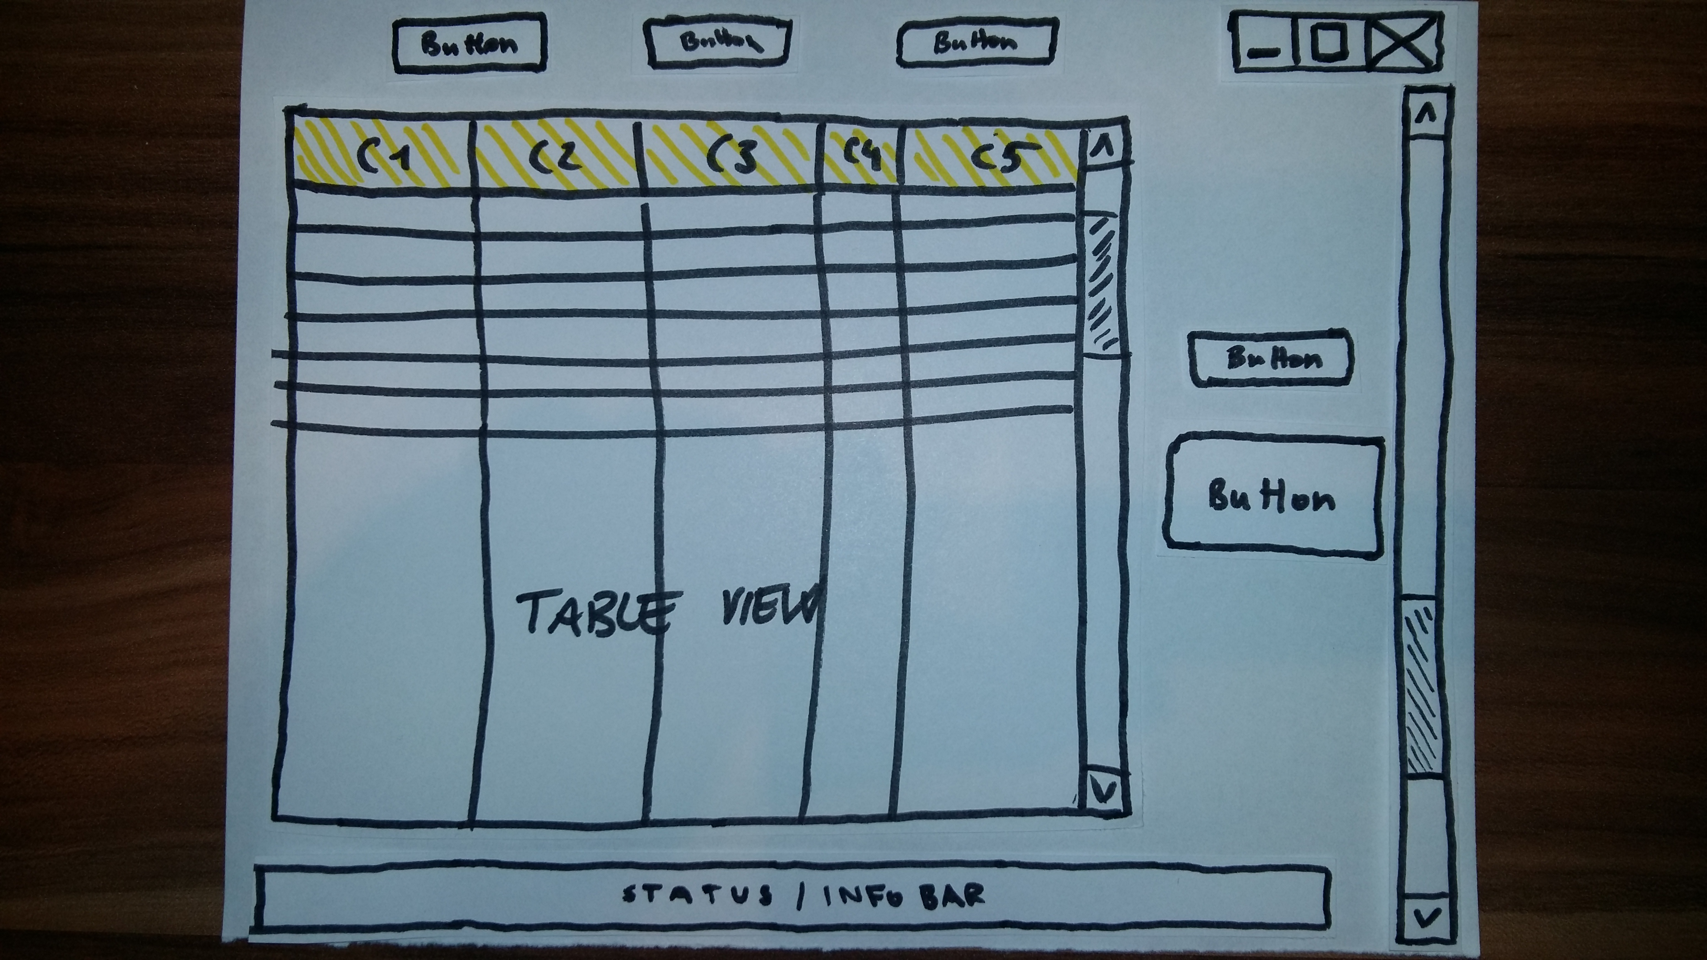

Submenu example – version 2

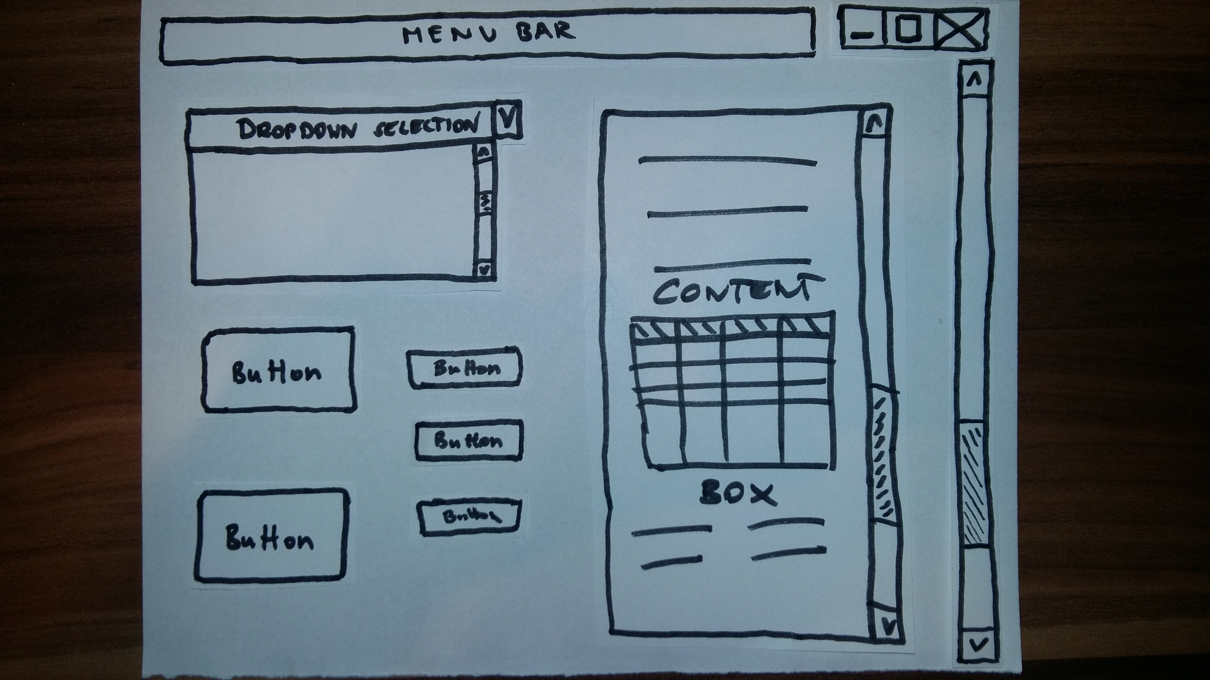

Each submenu offers different functionalities such as creating and editing tables or displaying summaries and reports with special properties and options, each fitting to the user selected in the main menu.